**[](https://apsche.smartinternz.com/Student/guided_project_info/6486)**[Toggle navigation](https://apsche.smartinternz.com/Student/guided_project_info/6486)

* [**0**](https://apsche.smartinternz.com/Student/guided_project_info/6486)
* [**Dashboard**](https://apsche.smartinternz.com/Student/dashboard)
* [**Internship**](https://apsche.smartinternz.com/Student/externships)
* [**Support**](https://apsche.smartinternz.com/Student/support)
* [**Training Calendar**](https://apsche.smartinternz.com/Student/training_calendar)
* [**Guided Project**](https://apsche.smartinternz.com/Student/guided_project_info/6486#menu1)
* [**Project Workspace**](https://apsche.smartinternz.com/Student/guided_project_workspace/6486)



* Implementing CRM For Result Tracking Of A Candidate With Internal Marks - (ADMIN)
  + Create Salesforce Org
    - Creating Developer Org
    - Account Activation
  + Object
  + What Is A Tab?
  + Lightning App
  + Fields And Relationship
  + Users
  + User Adoption
  + What Are Reports?
  + Dashboards

**Creating Developer Org**

Creating a developer org in salesforce.

1. Go to developers.salesforce.com/Signup
2. Click on sign up.
3. On the sign-up form, enter the following details:
   1. First name & Last name
   2. Email
   3. Role: Developer
   4. Company: College Name
   5. County: India
   6. Postal Code: pin code
   7. Username: should be a combination of your name and company

This need not be an actual email id, you can give anything in the format: [username@organization.com](mailto:username@organization.com)

Click on sign up after filling these.

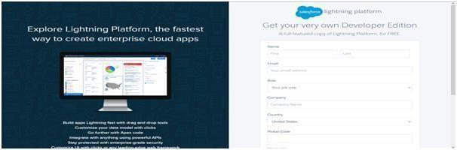

**[](https://apsche.smartinternz.com/Student/guided_project_info/6486)**[Toggle navigation](https://apsche.smartinternz.com/Student/guided_project_info/6486)

* [**0**](https://apsche.smartinternz.com/Student/guided_project_info/6486)
* [**Dashboard**](https://apsche.smartinternz.com/Student/dashboard)
* [**Internship**](https://apsche.smartinternz.com/Student/externships)
* [**Support**](https://apsche.smartinternz.com/Student/support)
* [**Training Calendar**](https://apsche.smartinternz.com/Student/training_calendar)
* [**Guided Project**](https://apsche.smartinternz.com/Student/guided_project_info/6486#menu1)
* [**Project Workspace**](https://apsche.smartinternz.com/Student/guided_project_workspace/6486)

* Implementing CRM For Result Tracking Of A Candidate With Internal Marks - (ADMIN)
  + Create Salesforce Org
    - Creating Developer Org
    - Account Activation
  + Object
  + What Is A Tab?
  + Lightning App
  + Fields And Relationship
  + Users
  + User Adoption
  + What Are Reports?
  + Dashboards

**Account Activation**

Go to the inbox of the email that you used while signing up. Click on the verify account to activate your account. The email may take 5-10mins, as

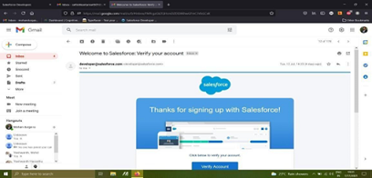

Login to Your Salesforce Account

1. Go to salesforce.com and click on login.

2. Enter the username and password that you just created.

3. After login this is the home page which you will see.

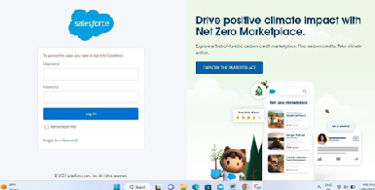

*Salesforce Login*

https://login.salesforce.com

Login to Your Salesforce Account

1. Go to salesforce.com and click on login.

2. Enter the username and password that you just created.

3. After login this is the home page which you will see.

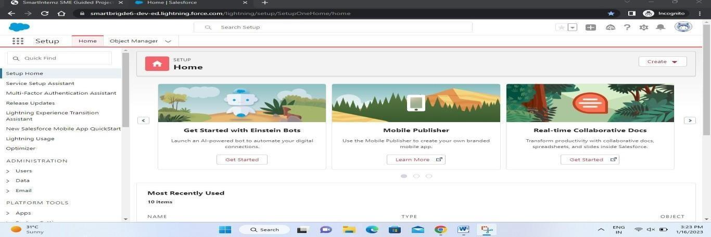

Salesforce Login htttps://login.salesforce.com

**[](https://apsche.smartinternz.com/Student/guided_project_info/6486)**[Toggle navigation](https://apsche.smartinternz.com/Student/guided_project_info/6486)

* [**0**](https://apsche.smartinternz.com/Student/guided_project_info/6486)
* [**Dashboard**](https://apsche.smartinternz.com/Student/dashboard)
* [**Internship**](https://apsche.smartinternz.com/Student/externships)
* [**Support**](https://apsche.smartinternz.com/Student/support)
* [**Training Calendar**](https://apsche.smartinternz.com/Student/training_calendar)
* [**Guided Project**](https://apsche.smartinternz.com/Student/guided_project_info/6486#menu1)
* [**Project Workspace**](https://apsche.smartinternz.com/Student/guided_project_workspace/6486)



* Implementing CRM For Result Tracking Of A Candidate With Internal Marks - (ADMIN)
  + Create Salesforce Org
    - Creating Developer Org
    - Account Activation
  + Object
    - Creation Of Semester Object For Candidate Internal Result Card
  + What Is A Tab?
  + Lightning App
  + Fields And Relationship
  + Users
  + User Adoption
  + What Are Reports?
  + Dashboards

**Creation Of Semester Object For Candidate Internal Result Card**

1. Click on the gear icon and then select Setup.

2. Click on the object manager tab just beside the home tab.

3. After the above steps, have a look on the extreme right you will find a Create Dropdownclick on that and select Custom Object.

4. On the Custom Object Definition page, create the object as follows:

5. Label: Semester

6. Plural Label: Semesters

7. Record Name: Semester Name

8. Check the Allow Reports

9. Check the Allow Search

10.Click Save.

In the same way create **4**more objects as **Candidate**, **Course Details**, **Lecturer Details** and **Internal results**.

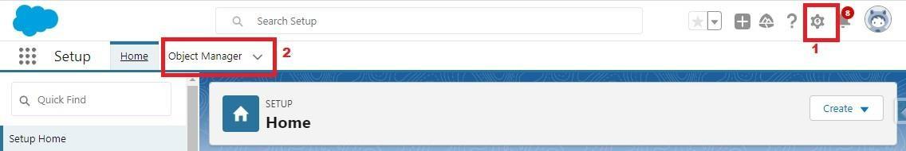

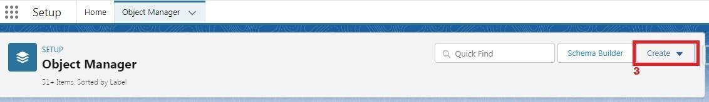

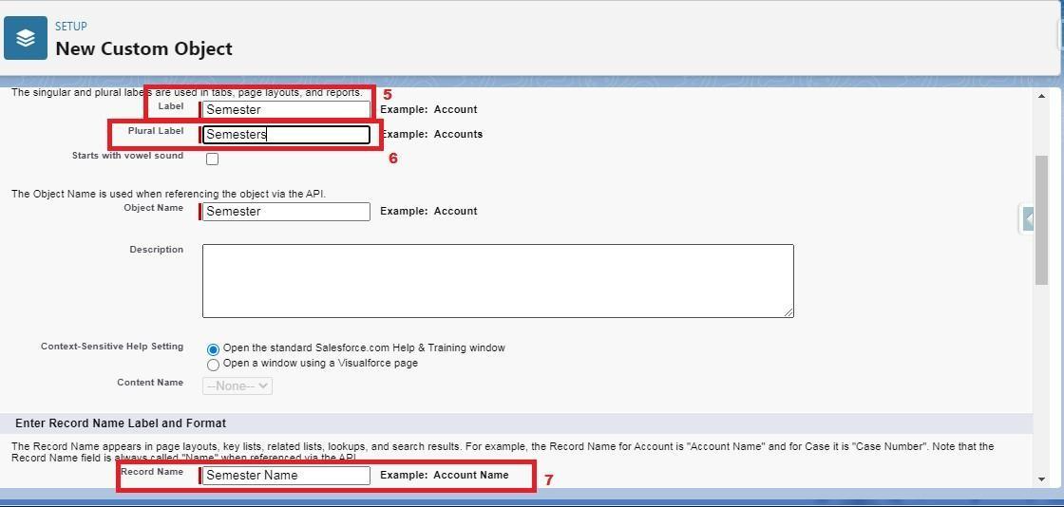  
  
  
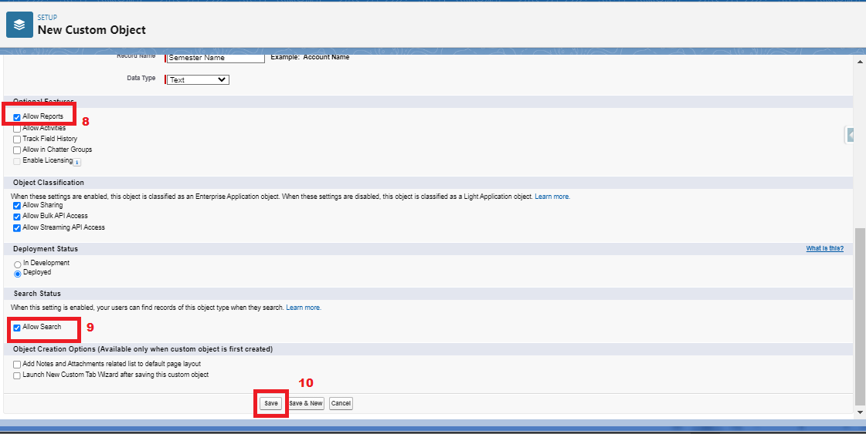

**](https://apsche.smartinternz.com/Student/guided_project_info/6486)**[Toggle navigation](https://apsche.smartinternz.com/Student/guided_project_info/6486)

* [**0**](https://apsche.smartinternz.com/Student/guided_project_info/6486)
* [**Dashboard**](https://apsche.smartinternz.com/Student/dashboard)
* [**Internship**](https://apsche.smartinternz.com/Student/externships)
* [**Support**](https://apsche.smartinternz.com/Student/support)
* [**Training Calendar**](https://apsche.smartinternz.com/Student/training_calendar)
* [**Guided Project**](https://apsche.smartinternz.com/Student/guided_project_info/6486#menu1)
* [**Project Workspace**](https://apsche.smartinternz.com/Student/guided_project_workspace/6486)

* Implementing CRM For Result Tracking Of A Candidate With Internal Marks - (ADMIN)
  + Create Salesforce Org
    - Creating Developer Org
    - Account Activation
  + Object
    - Creation Of Semester Object For Candidate Internal Result Card
  + What Is A Tab?
    - Creation Of Semester Tab For Candidate Internal Result Card
  + Lightning App
  + Fields And Relationship
  + Users
  + User Adoption
  + What Are Reports?
  + Dashboards

**Creation Of Semester Tab For Candidate Internal Result Card**

Now create a custom tab. Click the Home tab.

1. Enter Tabs in Quick Find and select Tabs.

2. Under Custom Object Tabs, click New.

3. For Object, select Semester.

4. For Tab Style, select any icon.

5. Leave all defaults as is. Click Next, Next, and Save

6. In the same way create Tabs for all Custom Objects -Candidate, Course Details, Lecturer Details, Internal results .

**](https://apsche.smartinternz.com/Student/guided_project_info/6486)**[Toggle navigation](https://apsche.smartinternz.com/Student/guided_project_info/6486)

* [**0**](https://apsche.smartinternz.com/Student/guided_project_info/6486)
* [**Dashboard**](https://apsche.smartinternz.com/Student/dashboard)
* [**Internship**](https://apsche.smartinternz.com/Student/externships)
* [**Support**](https://apsche.smartinternz.com/Student/support)
* [**Training Calendar**](https://apsche.smartinternz.com/Student/training_calendar)
* [**Guided Project**](https://apsche.smartinternz.com/Student/guided_project_info/6486#menu1)
* [**Project Workspace**](https://apsche.smartinternz.com/Student/guided_project_workspace/6486)

* Implementing CRM For Result Tracking Of A Candidate With Internal Marks - (ADMIN)
  + Create Salesforce Org
    - Creating Developer Org
    - Account Activation
  + Object
    - Creation Of Semester Object For Candidate Internal Result Card
  + What Is A Tab?
    - Creation Of Semester Tab For Candidate Internal Result Card
  + Lightning App
    - Create The Candidate Internal Result Card App
  + Fields And Relationship
  + Users
  + User Adoption
  + What Are Reports?
  + Dashboards

**Lightning App**

Apps in Salesforce are a group of tabs that help the application function by working together as aunit. It has a name, a logo, and a particular set of tabs. The simplest app usually has just two tabs. There are two types of app –

**1. Standard App**: Standard apps come with every occurrence of Salesforce as default. Many features like Sales, Marketing, Community, call center, content, Salesforce chatter, App Launcher, etc are present in it.

**Note:** The description, Logo, and Label of standard app cannot be altered.

**2. Custom Apps:** Custom apps are created according to need of user. Custom Apps are made by using standard and custom tabs together.

**Note:** Logos for Custom Apps can be changed.

**[](https://apsche.smartinternz.com/Student/guided_project_info/6486)**[Toggle navigation](https://apsche.smartinternz.com/Student/guided_project_info/6486)

* [**0**](https://apsche.smartinternz.com/Student/guided_project_info/6486)
* [**Dashboard**](https://apsche.smartinternz.com/Student/dashboard)
* [**Internship**](https://apsche.smartinternz.com/Student/externships)
* [**Support**](https://apsche.smartinternz.com/Student/support)
* [**Training Calendar**](https://apsche.smartinternz.com/Student/training_calendar)
* [**Guided Project**](https://apsche.smartinternz.com/Student/guided_project_info/6486#menu1)
* [**Project Workspace**](https://apsche.smartinternz.com/Student/guided_project_workspace/6486)

* Implementing CRM For Result Tracking Of A Candidate With Internal Marks - (ADMIN)
  + Create Salesforce Org
    - Creating Developer Org
    - Account Activation
  + Object
    - Creation Of Semester Object For Candidate Internal Result Card
  + What Is A Tab?
    - Creation Of Semester Tab For Candidate Internal Result Card
  + Lightning App
    - Create The Candidate Internal Result Card App
  + Fields And Relationship
    - Creation Of Text Field On "Lecturer Details" & Look Up Field For The “Candidate” Object
    - Creation Of Auto Number Field On Candidate Object, Number Field On Course Details Object & Formula Field Course Details Object
  + Users
  + User Adoption
  + What Are Reports?
  + Dashboards

**Creation Of Text Field On "Lecturer Details" & Look Up Field For The “Candidate” Object**

1.Click the gear icon and select Setup. This launches Setup in a new tab.

2. Click the Object Manager tab next to Home.

3. Select Lecturer Details

4. Select Fields & Relationships from the left navigation

5. Click New

6. Select the Text as the Data Type, click next.

7. For Field Label, enter Lecturer Role

8. Enter Length 40

9. Click Next, Next, then Save & New.

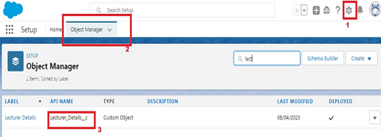  
  
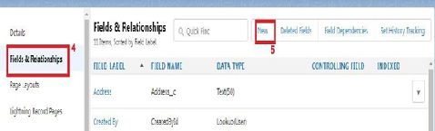

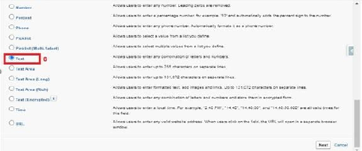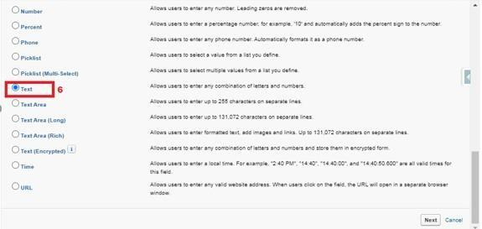

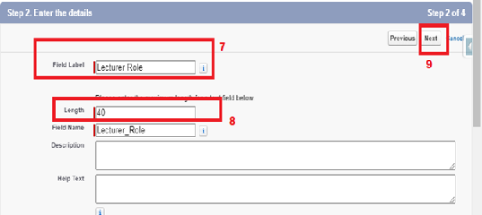

Now Let’s create a Lookup field on candidate object

1. Click the gear icon and select Setup. This launches Setup in a new tab.

2. Click the Object Manager tab next to Home.

3. Select candidate.

4. Select Fields & Relationships from the left navigation

5. Click New

6. Select the lookup as the Data Type, then click Next.

7. In related select Semester

8. For Field Label Semester Name, enter.

9. Click Next, Next, then Save & New.





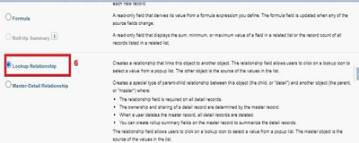

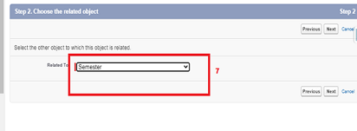

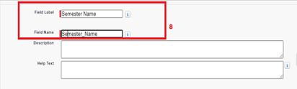

Note- Similarly create all lookup fields on their respective objects.

**[](https://apsche.smartinternz.com/Student/guided_project_info/6486)**[Toggle navigation](https://apsche.smartinternz.com/Student/guided_project_info/6486)

* [**0**](https://apsche.smartinternz.com/Student/guided_project_info/6486)
* [**Dashboard**](https://apsche.smartinternz.com/Student/dashboard)
* [**Internship**](https://apsche.smartinternz.com/Student/externships)
* [**Support**](https://apsche.smartinternz.com/Student/support)
* [**Training Calendar**](https://apsche.smartinternz.com/Student/training_calendar)
* [**Guided Project**](https://apsche.smartinternz.com/Student/guided_project_info/6486#menu1)
* [**Project Workspace**](https://apsche.smartinternz.com/Student/guided_project_workspace/6486)



* Implementing CRM For Result Tracking Of A Candidate With Internal Marks - (ADMIN)
  + Create Salesforce Org
    - Creating Developer Org
    - Account Activation
  + Object
    - Creation Of Semester Object For Candidate Internal Result Card
  + What Is A Tab?
    - Creation Of Semester Tab For Candidate Internal Result Card
  + Lightning App
    - Create The Candidate Internal Result Card App
  + Fields And Relationship
    - Creation Of Text Field On "Lecturer Details" & Look Up Field For The “Candidate” Object
    - Creation Of Auto Number Field On Candidate Object, Number Field On Course Details Object & Formula Field Course Details Object
  + Users
  + User Adoption
  + What Are Reports?
  + Dashboards

**Creation Of Auto Number Field On Candidate Object, Number Field On Course Details Object & Formula Field Course Details Object**

Let’s create a Number field on Course Details object

1. Click the gear icon and select Setup. This launches Setup in a new tab.

2. Click the Object Manager tab next to Home.

3. Select Course Detail.

4. Select Fields & Relationships from the left navigation

4. Click New & select number field, click Next

6. For Field Label Duration, enter.

7. Give Help Text- Enter Course duration value in Years

8. Click Next, Next, then Save & New.



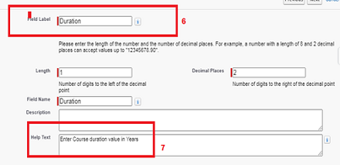

Now Let’s create a Formula field on Internal Results object

1. Click the gear icon and select Setup. This launches Setup in a new tab.

2. Click the Object Manager tab next to Home.

3. Select Internal results.

4. Select Fields & Relationships from the left navigation.

5. Click New

6. Select the Formula as the Data Type, then click Next.

7. Give field label Candidate Roll Number

8. Select formula return type text, Click Next

9. Click Insert Field

10.Create and insert formula Candidate r.Candidate_Roll_Number   c, and then click Insert.

11.Click Next, Next, then Save.





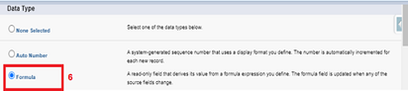

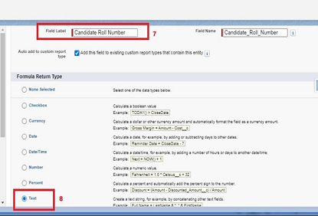

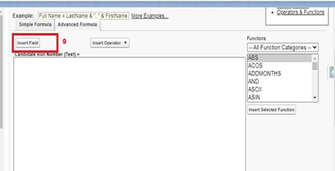

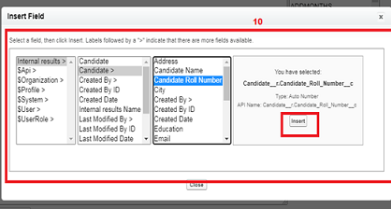

Now Let’s create an auto number field on Candidate object

1. Click the gear icon and select Setup. This launches Setup in a new tab.

2. Click the Object Manager tab next to Home.

3. Select Candidate.

4. Select Fields & Relationships from the left navigation

5. Click New

6. Select the Auto Number as the Data Type, then click Next.

7. For Field Label Candidate enter Roll Number.

8. Give a display format

9. Click Next, Next, then Save & New.





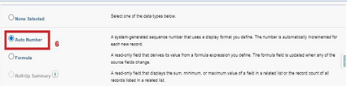

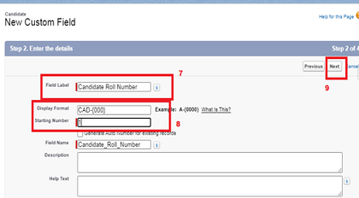

**](https://apsche.smartinternz.com/Student/guided_project_info/6486)**[Toggle navigation](https://apsche.smartinternz.com/Student/guided_project_info/6486)

* [**0**](https://apsche.smartinternz.com/Student/guided_project_info/6486)
* [**Dashboard**](https://apsche.smartinternz.com/Student/dashboard)
* [**Internship**](https://apsche.smartinternz.com/Student/externships)
* [**Support**](https://apsche.smartinternz.com/Student/support)
* [**Training Calendar**](https://apsche.smartinternz.com/Student/training_calendar)
* [**Guided Project**](https://apsche.smartinternz.com/Student/guided_project_info/6486#menu1)
* [**Project Workspace**](https://apsche.smartinternz.com/Student/guided_project_workspace/6486)

* Implementing CRM For Result Tracking Of A Candidate With Internal Marks - (ADMIN)
  + Create Salesforce Org
    - Creating Developer Org
    - Account Activation
  + Object
    - Creation Of Semester Object For Candidate Internal Result Card
  + What Is A Tab?
    - Creation Of Semester Tab For Candidate Internal Result Card
  + Lightning App
    - Create The Candidate Internal Result Card App
  + Fields And Relationship
    - Creation Of Text Field On "Lecturer Details" & Look Up Field For The “Candidate” Object
    - Creation Of Auto Number Field On Candidate Object, Number Field On Course Details Object & Formula Field Course Details Object
  + Users
    - Creating A User
  + User Adoption
  + What Are Reports?
  + Dashboards

**Creating A User**

1. From Setup, in the Quick Find box, enter Users.

2. Select Users.

3. Click New User.

4. Enter the First Name, Class, Last Name, Teacher and (Your) email address anda unique username in the form of an email address. By default, the username is the same as the email address.

5. Select a User License as salesforce.

NOTE- As Salesforce license can only be used by 2 Users at a time in Dev Org, so If you don’t find salesforce license then deactivate a user who has salesforce license Or change the license type from Salesforce to any other.

6. Select a profile as Standard user.

7. Check Generate new password and notify the user immediately to have the user’s login name and a temporary password emailed to your email.  
  
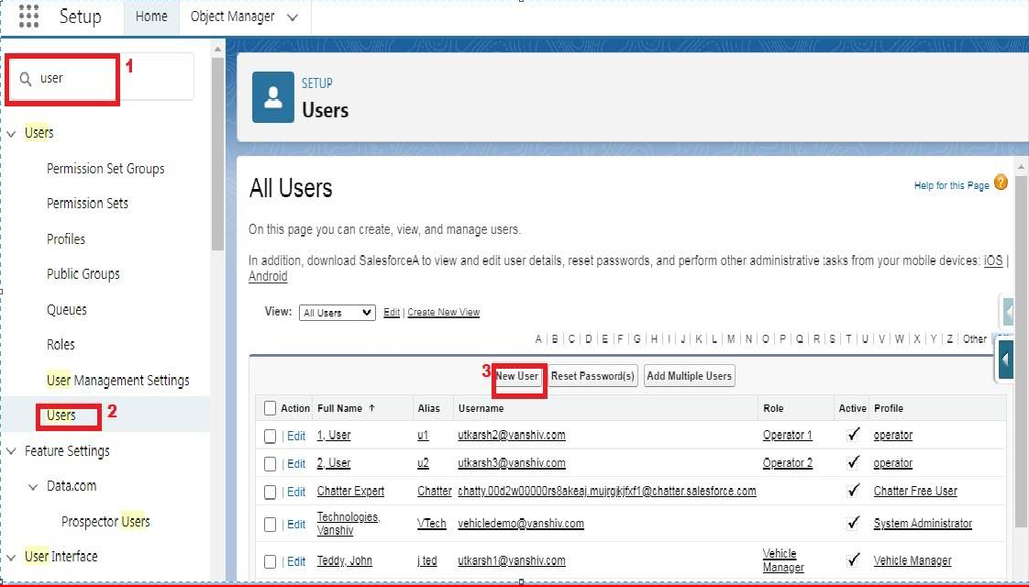

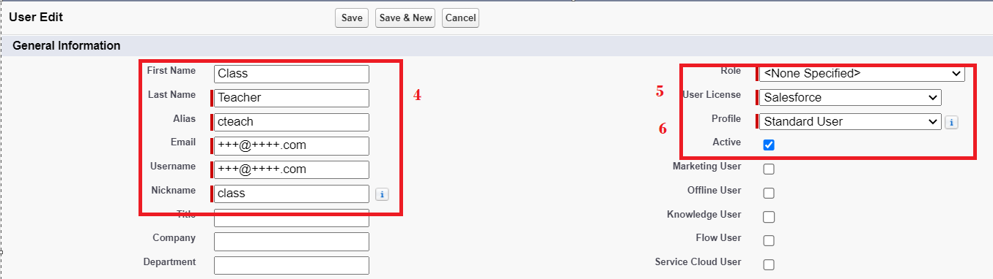

**[](https://apsche.smartinternz.com/Student/guided_project_info/6486)**[Toggle navigation](https://apsche.smartinternz.com/Student/guided_project_info/6486)

* [**0**](https://apsche.smartinternz.com/Student/guided_project_info/6486)
* [**Dashboard**](https://apsche.smartinternz.com/Student/dashboard)
* [**Internship**](https://apsche.smartinternz.com/Student/externships)
* [**Support**](https://apsche.smartinternz.com/Student/support)
* [**Training Calendar**](https://apsche.smartinternz.com/Student/training_calendar)
* [**Guided Project**](https://apsche.smartinternz.com/Student/guided_project_info/6486#menu1)
* [**Project Workspace**](https://apsche.smartinternz.com/Student/guided_project_workspace/6486)

* Implementing CRM For Result Tracking Of A Candidate With Internal Marks - (ADMIN)
  + Create Salesforce Org
    - Creating Developer Org
    - Account Activation
  + Object
    - Creation Of Semester Object For Candidate Internal Result Card
  + What Is A Tab?
    - Creation Of Semester Tab For Candidate Internal Result Card
  + Lightning App
    - Create The Candidate Internal Result Card App
  + Fields And Relationship
    - Creation Of Text Field On "Lecturer Details" & Look Up Field For The “Candidate” Object
    - Creation Of Auto Number Field On Candidate Object, Number Field On Course Details Object & Formula Field Course Details Object
  + Users
    - Creating A User
  + User Adoption
    - Create Record (Course Details)
    - View Record (Course Details)
    - Delete Record (Course Details)
  + What Are Reports?
  + Dashboards

**Create Record (Course Details)**

Create Records on Course Details Objects

1. Click on App Launcher on left side of screen.

2. Search Candidate Internal Result Card App & click on it.

3. Click on Course Details tab.

4. Click new button

5. Fill all Course Details record details.

6. Click on Save Button.

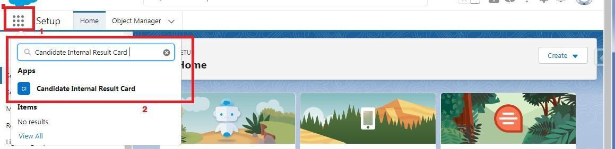

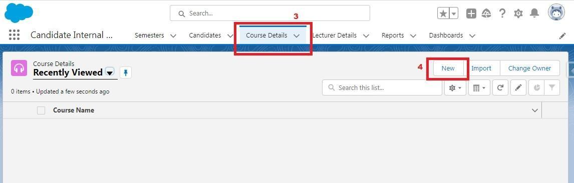

**[](https://apsche.smartinternz.com/Student/guided_project_info/6486)**[Toggle navigation](https://apsche.smartinternz.com/Student/guided_project_info/6486)

* [**0**](https://apsche.smartinternz.com/Student/guided_project_info/6486)
* [**Dashboard**](https://apsche.smartinternz.com/Student/dashboard)
* [**Internship**](https://apsche.smartinternz.com/Student/externships)
* [**Support**](https://apsche.smartinternz.com/Student/support)
* [**Training Calendar**](https://apsche.smartinternz.com/Student/training_calendar)
* [**Guided Project**](https://apsche.smartinternz.com/Student/guided_project_info/6486#menu1)
* [**Project Workspace**](https://apsche.smartinternz.com/Student/guided_project_workspace/6486)



* Implementing CRM For Result Tracking Of A Candidate With Internal Marks - (ADMIN)
  + Create Salesforce Org
    - Creating Developer Org
    - Account Activation
  + Object
    - Creation Of Semester Object For Candidate Internal Result Card
  + What Is A Tab?
    - Creation Of Semester Tab For Candidate Internal Result Card
  + Lightning App
    - Create The Candidate Internal Result Card App
  + Fields And Relationship
    - Creation Of Text Field On "Lecturer Details" & Look Up Field For The “Candidate” Object
    - Creation Of Auto Number Field On Candidate Object, Number Field On Course Details Object & Formula Field Course Details Object
  + Users
    - Creating A User
  + User Adoption
    - Create Record (Course Details)
    - View Record (Course Details)
    - Delete Record (Course Details)
  + What Are Reports?
  + Dashboards

**View Record (Course Details)**

Viewing the Records of Course Detail Object

1. Click on App Launcher on left side of screen.

2. Search Candidate Internal Result Card & click on it.

3. Click on Course details Tab.

4. Click on any record name. you can see the details of the Driver



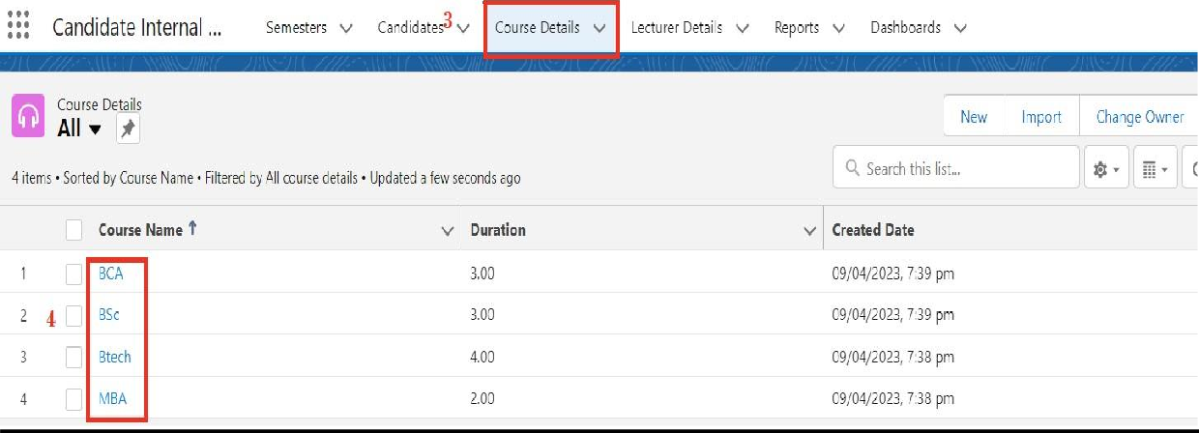

**[](https://apsche.smartinternz.com/Student/guided_project_info/6486)**[Toggle navigation](https://apsche.smartinternz.com/Student/guided_project_info/6486)

* [**0**](https://apsche.smartinternz.com/Student/guided_project_info/6486)
* [**Dashboard**](https://apsche.smartinternz.com/Student/dashboard)
* [**Internship**](https://apsche.smartinternz.com/Student/externships)
* [**Support**](https://apsche.smartinternz.com/Student/support)
* [**Training Calendar**](https://apsche.smartinternz.com/Student/training_calendar)
* [**Guided Project**](https://apsche.smartinternz.com/Student/guided_project_info/6486#menu1)
* [**Project Workspace**](https://apsche.smartinternz.com/Student/guided_project_workspace/6486)

* Implementing CRM For Result Tracking Of A Candidate With Internal Marks - (ADMIN)
  + Create Salesforce Org
    - Creating Developer Org
    - Account Activation
  + Object
    - Creation Of Semester Object For Candidate Internal Result Card
  + What Is A Tab?
    - Creation Of Semester Tab For Candidate Internal Result Card
  + Lightning App
    - Create The Candidate Internal Result Card App
  + Fields And Relationship
    - Creation Of Text Field On "Lecturer Details" & Look Up Field For The “Candidate” Object
    - Creation Of Auto Number Field On Candidate Object, Number Field On Course Details Object & Formula Field Course Details Object
  + Users
    - Creating A User
  + User Adoption
    - Create Record (Course Details)
    - View Record (Course Details)
    - Delete Record (Course Details)
  + What Are Reports?
  + Dashboards

**Delete Record (Course Details)**

Deleting Records of Course Details Object

1. Click on App Launcher on left side of screen.

2. Search Candidate Internal Result Card & click on it.

3. Click on Course details Tab.

4. Click on Arrow at right hand side on that Particular record.

5. Click delete and delete again.



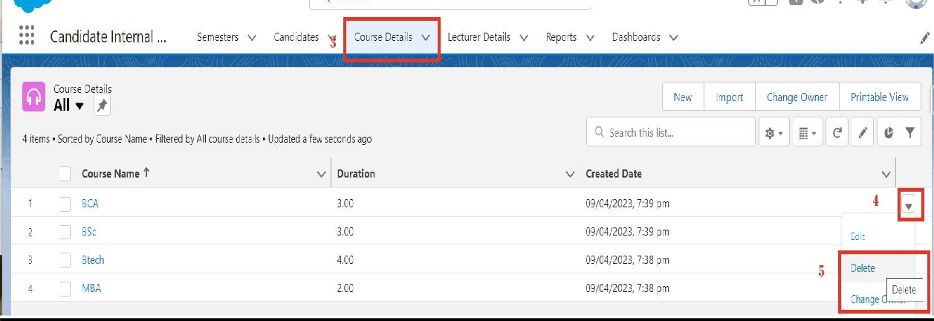

**[](https://apsche.smartinternz.com/Student/guided_project_info/6486)**[Toggle navigation](https://apsche.smartinternz.com/Student/guided_project_info/6486)

* [**0**](https://apsche.smartinternz.com/Student/guided_project_info/6486)
* [**Dashboard**](https://apsche.smartinternz.com/Student/dashboard)
* [**Internship**](https://apsche.smartinternz.com/Student/externships)
* [**Support**](https://apsche.smartinternz.com/Student/support)
* [**Training Calendar**](https://apsche.smartinternz.com/Student/training_calendar)
* [**Guided Project**](https://apsche.smartinternz.com/Student/guided_project_info/6486#menu1)
* [**Project Workspace**](https://apsche.smartinternz.com/Student/guided_project_workspace/6486)

* Implementing CRM For Result Tracking Of A Candidate With Internal Marks - (ADMIN)
  + Create Salesforce Org
    - Creating Developer Org
    - Account Activation
  + Object
    - Creation Of Semester Object For Candidate Internal Result Card
  + What Is A Tab?
    - Creation Of Semester Tab For Candidate Internal Result Card
  + Lightning App
    - Create The Candidate Internal Result Card App
  + Fields And Relationship
    - Creation Of Text Field On "Lecturer Details" & Look Up Field For The “Candidate” Object
    - Creation Of Auto Number Field On Candidate Object, Number Field On Course Details Object & Formula Field Course Details Object
  + Users
    - Creating A User
  + User Adoption
    - Create Record (Course Details)
    - View Record (Course Details)
    - Delete Record (Course Details)
  + What Are Reports?
    - Create Report
    - View Report
  + Dashboards

**Create Report**

1. Click App Launcher

2. Select Candidate Internal Result Card App

3. Click reports tab

4. Click New Report.

5. Click the report type as Semesters with Course Click Start report.

6. Customize your report, in group rows select - Course Name, in group column Select Duration (In this way we are making a Matrix Report).

7. Click refresh

8. Click save and run

9. Give report name – Candidate Internal Result Report

10.Click Save

NOTE: In this report you can see your all record of the object you selected for reporting (What you Selects in “Select a report type option”).



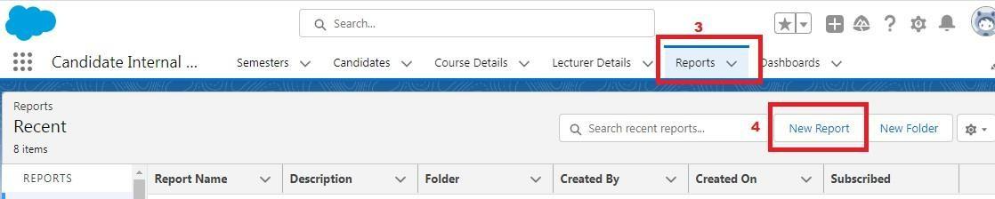

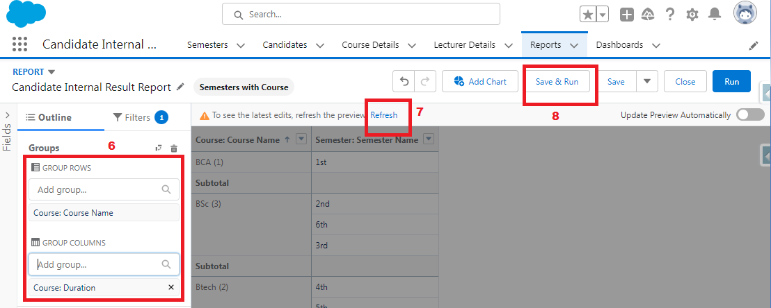  
  
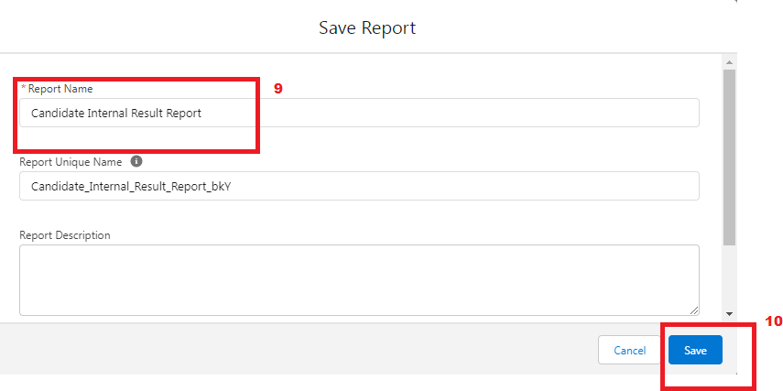

1.    On the report builder page, locate the "Fields" pane on the left-hand side.

2.    Find the field for which you want to create a bucket field and drag it to the report preview section.

3.    Click on the field in the report preview to open the field properties.

4.    In the field properties, locate the "Summarize" option and click the drop-down arrow.

5.    Select "Bucket Field" from the available options.

6.    In the bucket field settings, define the buckets based on your requirements. You can specify the bucket ranges, labels, and groupings.

7.    Click "OK" or "Apply" to save the bucket field settings.

8.    Customize the report layout and add any additional fields or filters as needed.

9.    Once you are satisfied with the report setup, click "Save" to save the report.

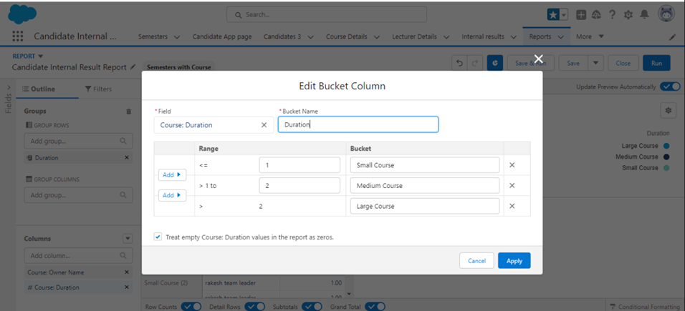

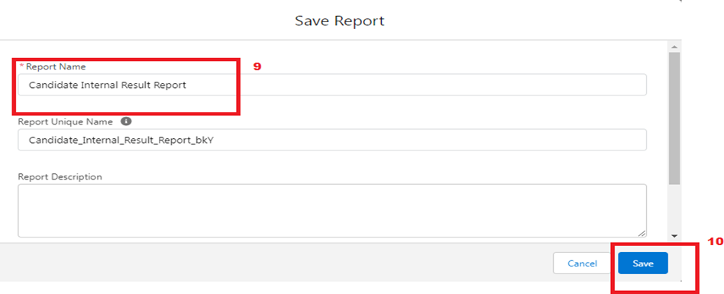

**](https://apsche.smartinternz.com/Student/guided_project_info/6486)**[Toggle navigation](https://apsche.smartinternz.com/Student/guided_project_info/6486)

* [**0**](https://apsche.smartinternz.com/Student/guided_project_info/6486)
* [**Dashboard**](https://apsche.smartinternz.com/Student/dashboard)
* [**Internship**](https://apsche.smartinternz.com/Student/externships)
* [**Support**](https://apsche.smartinternz.com/Student/support)
* [**Training Calendar**](https://apsche.smartinternz.com/Student/training_calendar)
* [**Guided Project**](https://apsche.smartinternz.com/Student/guided_project_info/6486#menu1)
* [**Project Workspace**](https://apsche.smartinternz.com/Student/guided_project_workspace/6486)

* Implementing CRM For Result Tracking Of A Candidate With Internal Marks - (ADMIN)
  + Create Salesforce Org
    - Creating Developer Org
    - Account Activation
  + Object
    - Creation Of Semester Object For Candidate Internal Result Card
  + What Is A Tab?
    - Creation Of Semester Tab For Candidate Internal Result Card
  + Lightning App
    - Create The Candidate Internal Result Card App
  + Fields And Relationship
    - Creation Of Text Field On "Lecturer Details" & Look Up Field For The “Candidate” Object
    - Creation Of Auto Number Field On Candidate Object, Number Field On Course Details Object & Formula Field Course Details Object
  + Users
    - Creating A User
  + User Adoption
    - Create Record (Course Details)
    - View Record (Course Details)
    - Delete Record (Course Details)
  + What Are Reports?
    - Create Report
    - View Report
  + Dashboards

**View Report**

1. Click on App Launcher on left side of screen.

2. Search Candidate Internal Result Card App & click on it.

3. Click on Reports Tab.

4. Click on Candidate Internal Result Report and see records.



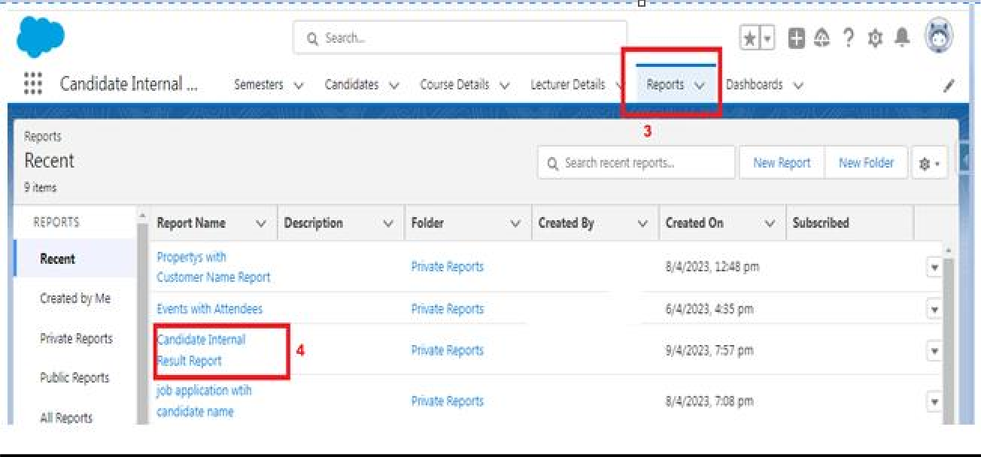

**[](https://apsche.smartinternz.com/Student/guided_project_info/6486)**[Toggle navigation](https://apsche.smartinternz.com/Student/guided_project_info/6486)

* [**0**](https://apsche.smartinternz.com/Student/guided_project_info/6486)
* [**Dashboard**](https://apsche.smartinternz.com/Student/dashboard)
* [**Internship**](https://apsche.smartinternz.com/Student/externships)
* [**Support**](https://apsche.smartinternz.com/Student/support)
* [**Training Calendar**](https://apsche.smartinternz.com/Student/training_calendar)
* [**Guided Project**](https://apsche.smartinternz.com/Student/guided_project_info/6486#menu1)
* [**Project Workspace**](https://apsche.smartinternz.com/Student/guided_project_workspace/6486)

* Implementing CRM For Result Tracking Of A Candidate With Internal Marks - (ADMIN)
  + Create Salesforce Org
    - Creating Developer Org
    - Account Activation
  + Object
    - Creation Of Semester Object For Candidate Internal Result Card
  + What Is A Tab?
    - Creation Of Semester Tab For Candidate Internal Result Card
  + Lightning App
    - Create The Candidate Internal Result Card App
  + Fields And Relationship
    - Creation Of Text Field On "Lecturer Details" & Look Up Field For The “Candidate” Object
    - Creation Of Auto Number Field On Candidate Object, Number Field On Course Details Object & Formula Field Course Details Object
  + Users
    - Creating A User
  + User Adoption
    - Create Record (Course Details)
    - View Record (Course Details)
    - Delete Record (Course Details)
  + What Are Reports?
    - Create Report
    - View Report
  + Dashboards
    - Create Dashboard
    - View Dashboard

**Create Dashboard**

1. Click on Dashboards tab from the Candidate Internal Result Card application.

2. Click on new dashboard.

3. Give name- Candidate Internal Result Card

4. Click create

5.  Give your dashboard a name and click on +component

6. Select the Candidate Internal Result Report which you created.

7. For the data visualization select any of the chart, table etc. as per your choice/requirement.

8. Click add.

9. Click save.

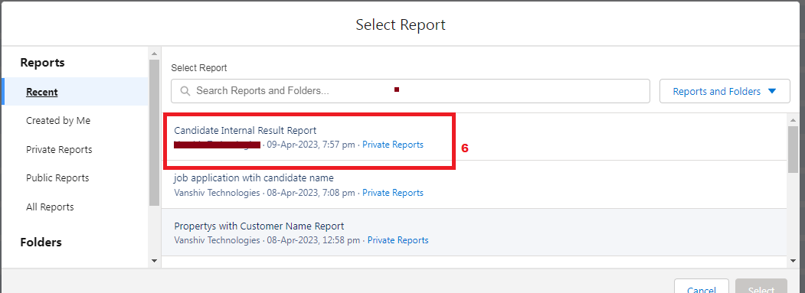

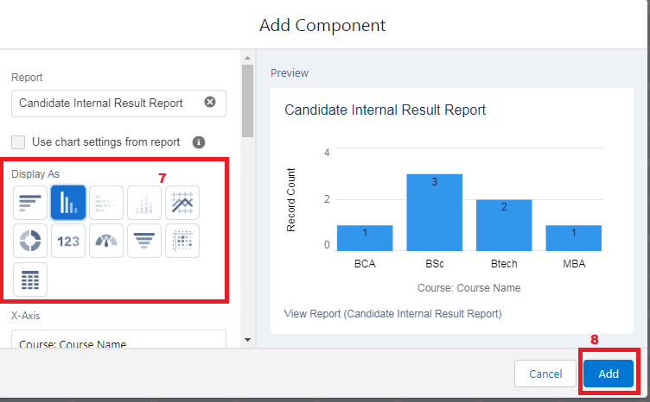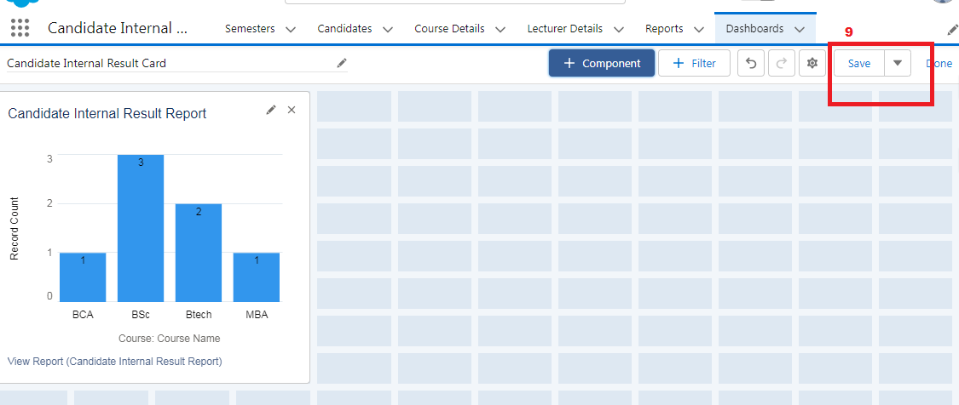

**[](https://apsche.smartinternz.com/Student/guided_project_info/6486)**[Toggle navigation](https://apsche.smartinternz.com/Student/guided_project_info/6486)

* [**0**](https://apsche.smartinternz.com/Student/guided_project_info/6486)
* [**Dashboard**](https://apsche.smartinternz.com/Student/dashboard)
* [**Internship**](https://apsche.smartinternz.com/Student/externships)
* [**Support**](https://apsche.smartinternz.com/Student/support)
* [**Training Calendar**](https://apsche.smartinternz.com/Student/training_calendar)
* [**Guided Project**](https://apsche.smartinternz.com/Student/guided_project_info/6486#menu1)
* [**Project Workspace**](https://apsche.smartinternz.com/Student/guided_project_workspace/6486)



* Implementing CRM For Result Tracking Of A Candidate With Internal Marks - (ADMIN)
  + Create Salesforce Org
    - Creating Developer Org
    - Account Activation
  + Object
    - Creation Of Semester Object For Candidate Internal Result Card
  + What Is A Tab?
    - Creation Of Semester Tab For Candidate Internal Result Card
  + Lightning App
    - Create The Candidate Internal Result Card App
  + Fields And Relationship
    - Creation Of Text Field On "Lecturer Details" & Look Up Field For The “Candidate” Object
    - Creation Of Auto Number Field On Candidate Object, Number Field On Course Details Object & Formula Field Course Details Object
  + Users
    - Creating A User
  + User Adoption
    - Create Record (Course Details)
    - View Record (Course Details)
    - Delete Record (Course Details)
  + What Are Reports?
    - Create Report
    - View Report
  + Dashboards
    - Create Dashboard
    - View Dashboard

**Create Dashboard**

1. Click on Dashboards tab from the Candidate Internal Result Card application.

2. Click on new dashboard.

3. Give name- Candidate Internal Result Card

4. Click create

5.  Give your dashboard a name and click on +component

6. Select the Candidate Internal Result Report which you created.

7. For the data visualization select any of the chart, table etc. as per your choice/requirement.

8. Click add.

9. Click save.



